2.15: 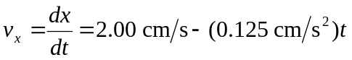
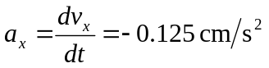
a)
b) 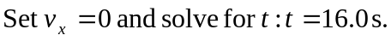
c) Setx = 50.0 cm and solve for t. This gives 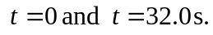 The turtle returns to the starting point after 32.0 s.
d) Turtle is 10.0 cm from starting point when x = 60.0 cm or x = 40.0 cm.
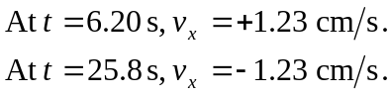
Set 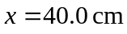 and solve for 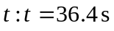(other root to the quadratic equation is negative and hence nonphysical).
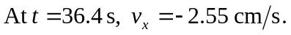
e)
